INFS3208 - 2018 Semester 2 Exam
Please contribute and add your solutions to the exam here :)

PART A
- A
- B
- A +1
- ? B? +1
- D (Also includes create/delete/snapshot)
- Not included B
- Not included Not included IN 2023
- A
- C? +1
- ? C? A
- A
- B A? D?+1
- B
- D
- B C+2
- D
- D
- Not included

PART B

Q1) Cloud computing is now a widely known computing paradigm.
a) List three kinds of service models of cloud computing with examples. (2 marks)
Infrastructure As A Service (IAAS): Google Compute Engine (GCE), AWS EC2
Platform As A Service (PAAS): Google App Engine, AWS Elastic Beanstalk
Software As A Service (SAAS): Google ecosystem, Microsoft Office

b) Explain the concept of cloud computing. List four essential characteristics of cloud computing with justifications. (2 marks)
Cloud computing is a specialized form of distributed computing that introduces utilization models for remotely provision scalable and measured resources.
Cloud computing characteristics: on-demand self-service usage, ubiquitous access, multitenancy, elasticity, measured usage, resiliency

Q2) Containers and virtual machines both allow their users to abstract the workload from the underlying hardware. However, there are important differences between these two approaches.
a) What is containerization technology? What are the benefits of using containers? (2 marks)
The process of taking an application and configuring it to run as a container is called containerization.
Benefits: Share OS kernel. Starts faster than VM. Use fraction of memory. One physical server/machine can run much more containers than VMs.

b) List three major differences between Virtualization and Containerization in cloud. (2 marks)
Multiple containers run atop the OS kernel directly -- far more lightweight.
Run anywhere: containers are able to run virtually anywhere.
Isolation: containers virtualise hardware at OS-level with a sandboxed view of the OS logically isolated from other apps.

Abstraction Level:
Virtualization: Operates at the hardware level, creating complete virtual machines.
Containerization: Operates at the application level, encapsulating applications and dependencies.

Resource Overhead:
Virtualization: Has higher resource overhead due to full OS emulation.
Containerization: Has lower resource overhead as it shares the host OS kernel.

Isolation and Portability:
Virtualization: Offers strong isolation but can be less portable.
Containerization: Provides lighter isolation and high portability for modern applications.

Q3) (4 marks) In cloud computing, a file system controls how data is stored and retrieved.
a) Explain the concepts of: Distributed File System (DFS), Clustered File System (CFS), and Network File System (NFS). Describe the differences among them. (2 marks)
- DFS is the distributed implementation of the time-sharing model of a file system, where multiple users can share files and storage resources.
- NFS is a DFS protocol originally developed by Sun Microsystem. NFS allows users on a client computer to access files over the network much like local storage. NFS is a client-server application, where users can view, store and update files on a remote computer.
- CFS is not a single server with a set of clients, but a cluster of servers that all work together to provide a higher performance. CFS is a DFS consisting of several simultaneously mounted servers that share the responsibilities, opposite to the single-server.

b) Describe the workflows of the Google File System (GFS) based on the figure below. (2 marks)
- When an application is reading a file, the app goes to the GFS client server. The client server sends the file name and chunk index to the GFS master.
- After receiving the request, the GFS master searches for the table and returns the chunk ID and the IP address including all of the chunk replicas.
- The client goes to the closest chunk and reads the file from the server.
- The GFS client caches the chunk operations and location.

Q4) (6 marks) A cloud database is a database that typically runs on a cloud computing platform, where its access is provided as a service.
a) What do SQL and NoSQL stand for? What are the major differences between SQL and NoSQL databases? (2 marks)
SQL stands for: relational database I think it means the acronym - Structured Query Language +1
NoSQL stands for: non-relational or distributed database Not only Structured Query Language +1
Major Differences are: SQL are table(tuple)-based while NoSQL are document-based, key-value, graph-based. SQL has a predefined schema while NoSQL databases have dynamic schema for unstructured data.

b) Convert the following RDF Graph to an XML representation. (4 marks)
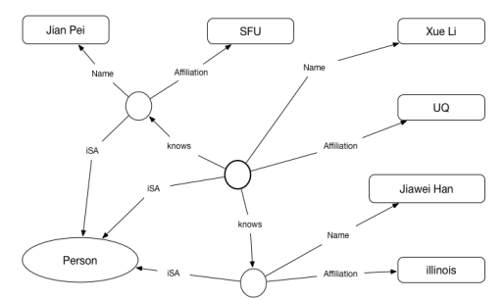
Not included?

Q5) (4 marks) Load balancing is a process of finding overloaded nodes and then transferring the extra load to other nodes.
a) Use examples to briefly explain the differences between Decentralized and Distributed Architectures in cloud. (2 marks)

b) There are many situations that can cause cloud infrastructure to be overloaded. Discuss the situations or problems that the load balancing would be needed. List and explain at least three kinds of situations/problems. (2 marks)

Q6) Spark
a) What are the benefits of using the MapReduce model in Spark over Hadoop? (3 marks)

b) You are given the following input text. Use the following diagram to illustrate the MapReduce algorithm. (5 marks)
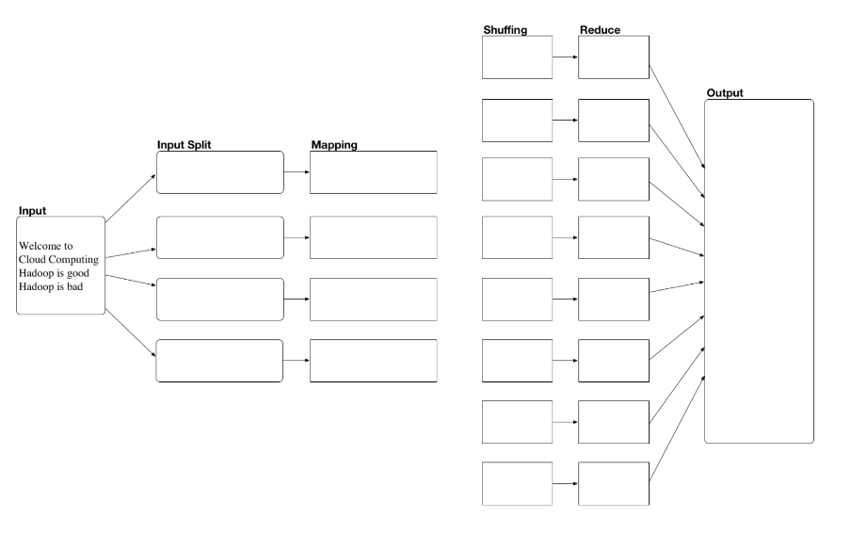
Split | Mapping
1: Welcome, to | 5: (Welcome, 1), (to, 1)
2: Cloud, Computing | 6: (Cloud, 1), (Computing, 1)
3: Hadoop, is, good | 7: (Hadoop, 1), (is, 1), (good, 1)
4: Hadoop, is, bad | 8: (Hadoop, 1), (is, 1), (bad, 1)

Shuffling | Reduce
9: Welcome, (1) | 17: Welcome, 1
10: to, (1) | 18: to, 1
11: Cloud, (1) | 19: Cloud, 1
12: Computing, (1) | 20: Computing, 1
13: Hadoop, (1,1) | 21: Hadoop, 2
14: is, (1,1) | 22: is, 2
15: good, (1) | 23: good, 1
16: bad, (1) | 24: bad, 1

Output
25: (Welcome, 1), (to, 1), (Cloud, 1), (Computing, 1), (Hadoop, 2), (is, 2), (good, 1), (bad, 1)

Q7)
a)

b)

Q8) NOT INCLUDED

